**Food**

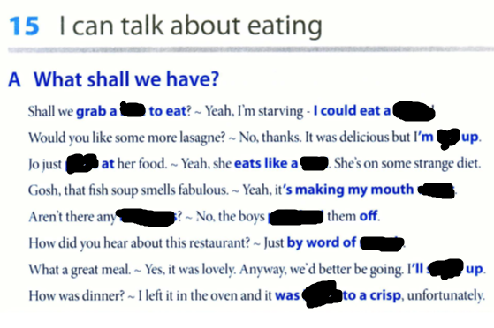

**burnt , settle, water , leftovers , bird , horse , full , bite , pick , mouth , polish ,**

**bite, horse, full, pick, bird, water, leftovers, polish, mouth, settle, burnt**

**cuisine…………………………**

Italian cuisine…………………..is one of the most exquisite

**have a craving……………………………..**

I have a criving……………………..for roast meet

Sweet tooth………………….

She has got a sweet tooth…………………She adores sweets

**whet my appetite………………………………..**

When I came home smell of fresh crunchy bread whet…………………………..my appetite

**pass…………………**

Would you care for a cup of coffee ? I will pass………………..this time

Go off……………….

Food went off……………..as a result the stench was obnoxious

Undernourished ……………………..

Thousands of children are undernourished…………………....They lack sufficient nutrients

Inedible…………………………..

That food is simply inedible……………………It’s poisonous

**helping ………………………..**

Can I ask for another helping………………………Of course

waften………………………..

Smell of home-made borsch wafted…………………. in the kitchen for hours

**starving…………………………**

I am starving……………………I could eat a horse

fussy……………………..

She is a fussy…………………eater

**grab ……………………….**

Could you wait a second. I will grab ……………….sth

**leftowers…………………….**

Could you throw leftowers………………………to the red bin

He is a teetotaler………………………….He avoids alcohol

**Split……………………….. , foot…………………….**

We could split………………………the bill 50/50 or if you are short of cash I can foot……………….the bill

Food verbs:

Nibble tough meat

Gorge on peanuts

Choke sweets

Chew with stone

Savour in ice cream

Peck at coke

Wolf down dry food

Slurp delicacies

1-2, 2-3, 3-4, 4-1, 5-8, 6-7, 7-5, 8-6

2. I know a fantastic  (*recipe/receipt*) for mushroom soup.   
  
3. Pass me the hot sauce. This meal is too  (*spicy/bland*).   
  
  
5. I can't eat that much. Whenever I eat a  (*heavy/light*) meal, I get sleepy.   
  
6. Don't eat that apple. It's  (*rotten/rot*).   
  
7. Meat that doesn't have a lot of fat is called  (*unfat/lean*) meat.   
  
8. Fresh squeezed juice is very  (*nutritious/nutritional*).   
  
9. In a restaurant, you can order your steak "rare", "medium", or "well " (*cooked/done*). 

2. When you're making this sauce, don't forget to  (stir/spin) it every 5 minutes.   
  
3. An  (appetizer/artichoke) is something you eat before the main course of a meal.   
  
4. Would you like some more potatoes? No, thanks. I'm  (complete/full).   
  
5. A very informal way of saying that you've eaten a lot is "I'm  (stuffed/complete)".   
  
6. People who are lactose-intolerant cannot eat (meat/dairy) products.   
  
9. We have two kinds of mineral water - sparking and  (unsparkling/still). 

|  |  |  |
| --- | --- | --- |
| 1. I added a bit of hot sauce to the soup to give it some more ____flavour___________. |  |  |
| 5. Please don't ___chew____________ with your mouth open; it's rude. |  |  |
| 8. Veronika sat in the bath, playing with the bubbles, and ____drinking_____ champagne. |  |  |
| 12. See those white parts on the strawberries? That means they're not ____unripe___________ yet. |  |  |
| 14. Mix all the dry ___ingredients____________ before adding the milk. |  |  |
| 15. You can choose a mild, medium, or hot __sauce_____________ for your dishes in the Indian restaurant we usually go to. |  |  |
| 16. This still tastes a little __bitter_____________; we'd better put some more sugar in it. |  |  |
| 17. He got sick at the barbecue after eating a hamburger that was still ______raw_________ in the middle. |  |  |

Dół formularza

Phrases and idioms

- …………………………….yourself

-…………………yourself at home

- wide…………………….of dishes

……………..the table , could you?

Don’t bother , I will …………………..up ,

We need to cut ……down…………………….on junk food

**tea, milk, nuts, beans, cakes, apple, cucumber, potato, fish**

1. I am ………………………..about computers
2. My car is the …………………………in my eye. I take care about it
3. He spilt the ……beans………………… it means he revealed the secret which I gave him
4. Don’t cry over spilt ……milk……………………..You should come to terms with that decision
5. I am not very keen on theatre. It’s not my cup of ……tea………………
6. My friend is extremely easy going . He is as cool as ………cucumber……………………
7. This new product is selling like hot ……cakes…………………..
8. He is so lazy . He doesn’t go anywhere. He’s a real couch……potato……………..
9. He can drink the whole bottle of whisky. He drinks like……fish………………….